**ECE(Microelectronic circuit and devices project)**

**Name Id**

**1,Solomon Mehabaw UGR/25389/14**

**2 Bereket Mamo ........ UGR/25895/14**

**3, Dawit Tamene ........ UGR/25412/14**

**SECTION-3**

**Year- 2016/2024(3rd year)**

**Voice and Text controlled Home Automation System Using Arduino Uno and bluetooth module(HC-05)**

**Introduction**

Home automation has become increasingly popular in recent years, as advancements in technology have made it easier to control and monitor various household devices and systems remotely or through automation . This project, is designed to control household appliances using voice commands and text inputs via a mobile application. By using good capabilities of the Arduino Uno, Bluetooth module, relay module, and other components, this system enables the user to control lamps and a fan and other devices with ease and convenience.

**Components and Circuit Diagram explanation**

**Components**

1,Arduino Uno: The central microcontroller that processes commands and controls other components

2,Bluetooth Module (HC-05): Facilitates/allow wireless communication between the Arduino uno and the mobile app.

3,Relay Module: Acts as a switch to control high-voltage devices like lamps and fans.

4,Transistor (2N2222): Used in the relay module for switching purposes.Used to drive the relay coils.

5,Diode (1N4007):Protects the circuit from back EMF generated when the relay coil is de-energized.Diodes (1N4007) are connected across the relay coils to prevent voltage spikes from damaging the transistors when the relays are de-energized.

6,2 Lamps (230V each): Controlled by the relay module to turn on and off based on commands.

7, Motor Fan (Ventilator): A 12V DC motor fan that can be controlled through the relay module based on commands

8,Resistor (1kΩ): Used in the control circuit to limit current to the base of the transistors.

9,12V DC Power Supply: provides the necessary power for all the connected device such as Arduino and other connected components.

10,Mobile Application: Used to send voice and text commands to the Arduino via Bluetooth.

11,Alternators: Two 230V, 50Hz alternators that provide the necessary power for the lamps.

**Reason for Choosing the Project**

This project was chosen due to the growing interest and demand for smart home systems that provide comfort, convenience, and energy efficiency. Voice and text control offer a user-friendly interface for managing household appliances, making it accessible to a wide range of users, including those with disabilities or mobility issues. And also offer for user to control home appliance effertlessely and reduce energy consumption

**Circuit Diagram Explanation**

circuit diagram is created using Proteus simulation software. Here's a detailed explanation of the connections and functionality:

1, Arduino Connections:

Digital Pins 2, 3, 4 : Connected to the base of the transistors Q1, Q2,

And Q3 through 1kΩ resistors (R1, R2, R3) respectively.TX/RX Pins : Connected to

the RX/TX pins of the Bluetooth module (HC-05).

2, Bluetooth Module (HC-05):

VCC: Connected to the 5V pin of the Arduino.

GND: Connected to the ground (GND) pin of the Arduino.

TXD: Connected to the RX pin of the Arduino.

RXD: Connected to the TX pin of the Arduino.

3, Relay Module:

Relays RL1, RL2, RL3: Each relay is controlled by an NPN transistor (2N2222). The relays are used to switch the high voltage (230V) appliances.

4, Transistors (Q1, Q2, Q3): The base of each transistor is connected to the Arduino through a 1kΩ resistor. When the Arduino outputs a HIGH signal, the transistor saturates, allowing current to flow through the relay coil.

5, Diodes (D1, D2, D3): Placed across the relay coils to protect the transistors from voltage spikes due to the inductive load of the relay coils.

6,High Voltage Appliances: Lamps (L1, L2): Connected to the relays RL1 and RL2 respectively. Fan: Connected to relay RL3

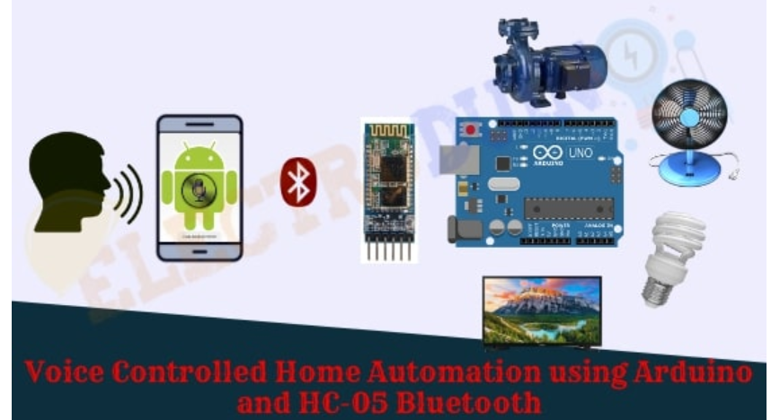

**Working of project**

The Arduino Uno serves as the central control unit, receiving commands from the Bluetooth module.The Bluetooth module establishes a wireless connection between the Arduino Uno and the mobile app, allowing for voice and text-based input. The relay module is used to switch the connected devices (lamps and motor fan) on and off based on the commands received from the Arduino Uno.The alternators provide the necessary 230V, 50Hz power to the lamps, while the 12V DC power supply powers the Arduino Uno, Bluetooth module, and the motor fan.

**steps of how project works**:

The Arduino initializes the Bluetooth module and sets up the pins connected to the relay module.The mobile app sends commands as text or voice input converted to text via Bluetooth to the Arduino. The Arduino reads the received command and determines the corresponding action ( turn on first light, turn off fan… ).Based on the command, the Arduino sends a signal to the appropriate relay. If the command is to turn on first light, the corresponding relay closes, allowing current to flow and light the lamp which means the Arduino sets the corresponding digital pin HIGH or LOW. This digital signal controls the base of the connected transistor via a 1kΩ resistor. When the pin is set HIGH, the transistor allows current to flow through the relay coil, closing the relay switch and powering the connected appliance.The system can be designed to send a confirmation back to the mobile app, indicating the successful execution of the command.

**Arduino code**

**//voice/text controlled home automation**

**//Department of Electronics and Communication Enginnering**

**// Micro Electronics And Circuits**

**///SEC -3**

**//YEAR-2016**

**// Name ID**

**//1, Solomon Mehabaw ........ UGR/25389/14**

**//2, Bereket Mamo ........ UGR/25895/14**

**//3, Dawit Tamene ........ UGR/25412/14**

**String voice;**

**const int relay_1=2;//Connect relay1 to pin 2( pin 2 of arduino to relay 1 using #define relay_1 2)**

**const int relay_2=3;//Connect relay2 to pin 3( pin 3 of arduino to relay 2 using #define relay_2 3)**

**const int relay_3=4;//Connect relay3 to pin 4( pin 4 of arduino to relay 3 using #define relay_3 4)**

**void setup()**

**{**

**// put your setup code here, to run once:**

**Serial.begin(9600);//Set rate for communicating with phone**

**pinMode(relay_1,OUTPUT);**

**pinMode(relay_2,OUTPUT);**

**pinMode(relay_3,OUTPUT);**

**}**

**void loop()**

**{**

**// put your main code here, to run repeatedly:**

**//Check if there is an available byte to read**

**while (Serial.available())**

**{**

**//to make stable**

**delay(3);**

**char x=Serial.read();**

**voice=voice+x;**

**}**

**if(voice.length()>0)**

**{**

**Serial.println(voice);**

**if(voice=="turn on first light")**

**{**

**digitalWrite(relay_1,HIGH);**

**}**

**else if (voice=="turn off first light")**

**{**

**digitalWrite(relay_1,LOW);**

**}**

**else if (voice=="turn on second light")**

**{**

**digitalWrite(relay_2,HIGH);**

**}**

**else if (voice=="turn off second light")**

**{**

**digitalWrite(relay_2,LOW);**

**}**

**else if (voice=="turn on fan")**

**{**

**digitalWrite(relay_3,HIGH);**

**}**

**else if (voice=="turn off fan")**

**{**

**digitalWrite(relay_3,LOW);**

**}**

**else if (voice=="turn on all")**

**{**

**turn_all();**

**}**

**else if (voice=="turn off all")**

**{**

**turn_off();**

**}**

**voice="";**

**}**

**}**

**void turn_all()**

**{**

**digitalWrite(relay_1,HIGH);**

**digitalWrite(relay_2,HIGH);**

**digitalWrite(relay_3,HIGH);**

**}**

**void turn_off()**

**{**

**digitalWrite(relay_1,LOW);**

**digitalWrite(relay_2,LOW);**

**digitalWrite(relay_3,LOW);**

**}**

**Applications**

**Home Automation**: Simplifies the control of household appliances.

**Accessibility**: The project can be particularly beneficial for individuals with disabilities or limited mobility such as elderly individuals , providing a hands-free and convenient way to control household devices.

**Safety and Security**: Automates lighting and other appliances, enhancing home security.

**Real-Life Application**s

**Smart Homes**: Integration of the system in modern homes for automated control of lights, fans, and other appliances.

**Office Automation**: Automating lighting and ventilation systems in offices to improve energy efficiency.

**Healthcare Facilities**: Assisting patients in controlling their environment with minimal effort.

**Conclusion**

The Voice and Text Home Automation System using Arduino Uno is an effective and innovative solution for modernizing home environments. By combining the Arduino Uno, Bluetooth module, relay module, and a mobile app, users can conveniently control their household devices using voice or text control in which system enhances convenience, accessibility, and energy efficiency

This project serves as an excellent foundation for anyone interested in home automation and the Internet of Things (IoT), and Voice and Text Home Automation stepping stone towards the development of more advanced smart home technologies.

**Reference**

- <https://nevonprojects.com/voice-controlled-home-automation/>

- https://www.electroduino.com/voice-controlled-home-automation-using-arduino-and-hc-05-bluetooth-module/

- https://www.youtube.com/watch?v=x0BXqbDmiHs